Carrington Event: The Solar Storm That Could Harm the Power Grid and Modern Civilization — The Ephemeris | Earth Moves

InstrumentsPhilosophyEphemerisStore
Home›The Ephemeris›Carrington Event: The Solar Storm That Could Harm the Power Grid and Disrupt Modern Civilization
Space Weather

Carrington Event: The Solar Storm That Could Harm the Power Grid and Disrupt Modern Civilization
What if a Carrington-level solar storm hit today? The 1859 event fried telegraphs now it could cost trillions of USD, blackout regions for years via transformer failures, and disrupt satellites & GPS. There is a 12% chance per decade—you can track it with Earth Moves Watch.
March 9, 2026·4 min read·Earth Moves
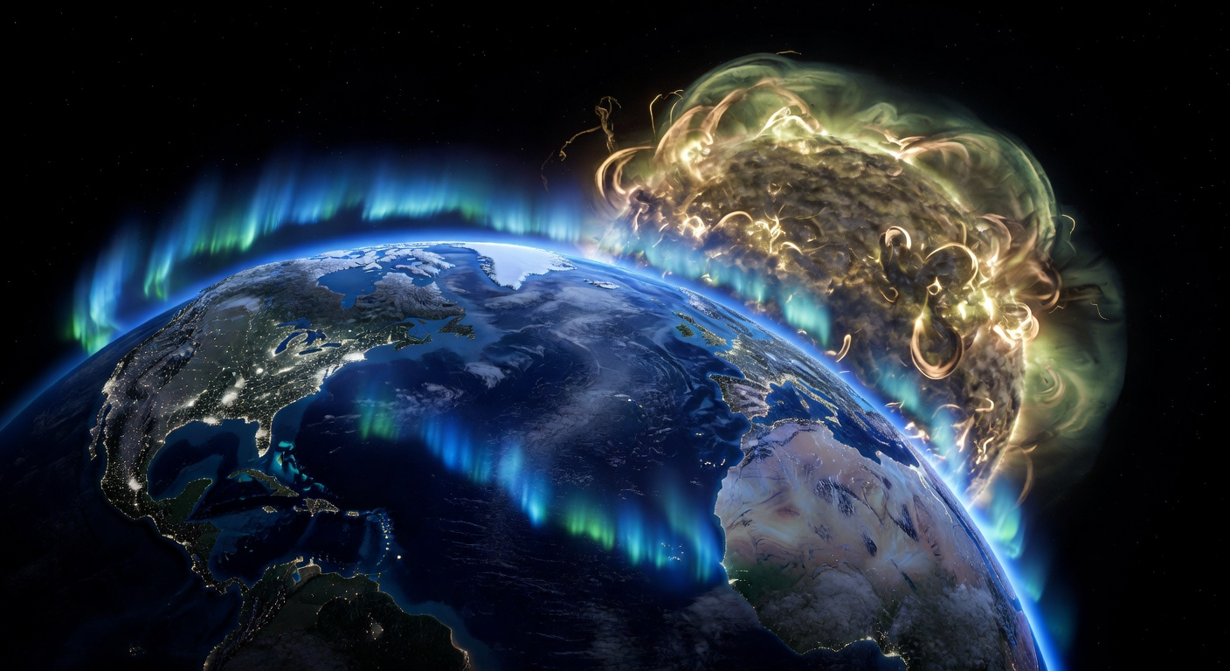Image: Generated by Earth Moves AI

Carrington Event: The Solar Storm That Could Harm the Power Grid and Disrupt Modern Civilisation
Our life-giving Sun is continously sending exploding burst of particles into space. These solar flares hits Earth from time to time, and it is what is making aurora borealis or northern lights at the North and South Pole areas. A Carrington-level solar storm is a huge explosion on the Sun that coincidentally hits Earth with an enormous force in the form of charged particles. When it hits Earth this storm will not only create spectacular aurora all the way down to Meditterean, it can also induce electricity in numerous hardware. The induced currents can overwhelm high-voltage transformers. This again will cause grids to fail across the most of the Northern and Southern hemisphere. Cascading blackouts. Satellites fail. GPS vanishes for weeks. Planes ground. Trade and digital communication halts.

What a Carrington Event Would Do to Modern Civilisation Today
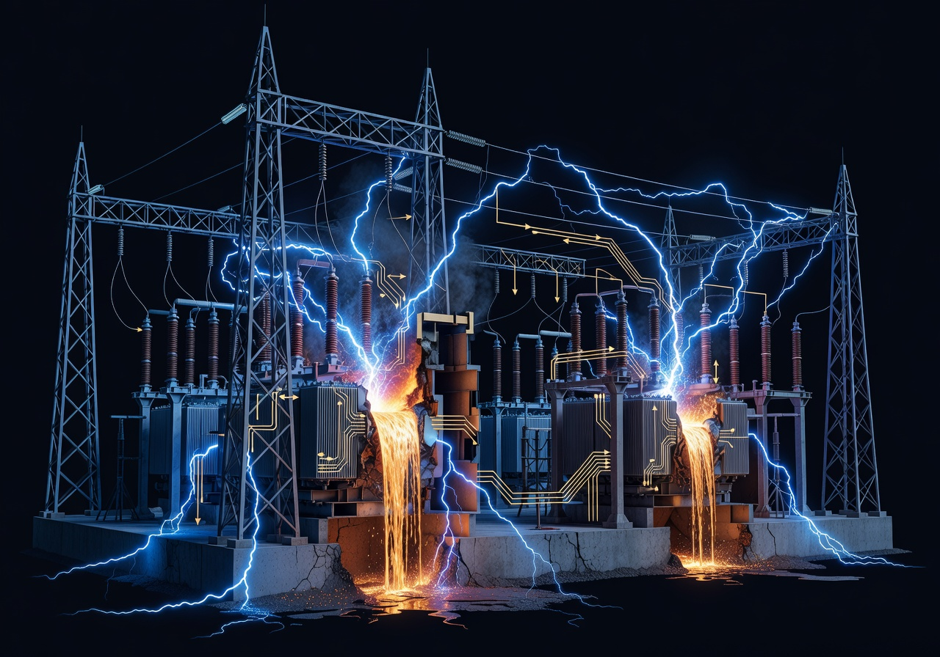Generated by Earth Moves AI
A Carrington-scale solar storm hitting Earth in 2027, with a vastly denser shell of satellites in orbit, could trigger a cascading technological collapse: intense geomagnetic currents might permanently damage hundreds or thousands of high-voltage transformers, causing continent-scale blackouts lasting months or even years until new hardware is manufactured and installed, while overheating and drag in the upper atmosphere, combined with radiation surges, could disable or deorbit much of the satellite fleet, wiping out GPS, weather forecasting, and a large fraction of global communications and remote sensing capacity in a matter of hours.
With internet backbone links, data centers, and cellular networks dependent on a stable grid and precise timing, large regions could lose connectivity, financial transactions, logistics systems, and many government functions, leading to trillions of dollars in losses and prolonged disruption of everything from just-in-time food supply chains to aviation, shipping, and emergency services; in the worst case, the sudden loss of space-based infrastructure plus long-duration power outages could push modern civilisation into a prolonged “slow-motion disaster” where societies remain physically intact but operate for years at a pre-digital or patchy, locally improvised technological level, struggling to rebuild satellite constellations and grid infrastructure under severe economic and political stress.

Reliving the 1859 Carrington Event
<lag nytt bilde heller av telegrafist som får lyn inn i telegraflinjen (det var jo flere telegrafister som fikk brannskader rundt ørene) og nordlys som sees ut av vinduet>
Generated by Earth Moves AI
Richard Carrington peered through his Kew Observatory refractor on 1 September 1859. He observed a white-light complex that blazed for 5 minutes across 4° of the solar disk. Seventeen hours later, the coronal mass ejection struck Earth.
Auroras was observed to 18°N in Hawaii and Colombia. Skies glowed "bright as day" from Caribbean to Queensland. Boston telegraph wires almost caught fire and operators got shock treatment at 1000 volts. Fires sparked in Pittsburgh and Dusseldorf.
Colaba, India, measured 5000 nanoTesla/min—five times more than the later 1989 Quebec storm. Carrington tied the solar flare to aurora. He measured that the plasma hurtled at 2000 km/s. In 1859 there were almost no electrical equipment installed on Earth, there were no sattellites, and no digital services to be harmed.
A Carrington level ejection happens quite often on the Sun, but it also needs to hit Earth, and Earth is a small target, thats why there has been few Carrington events the last hundred years.

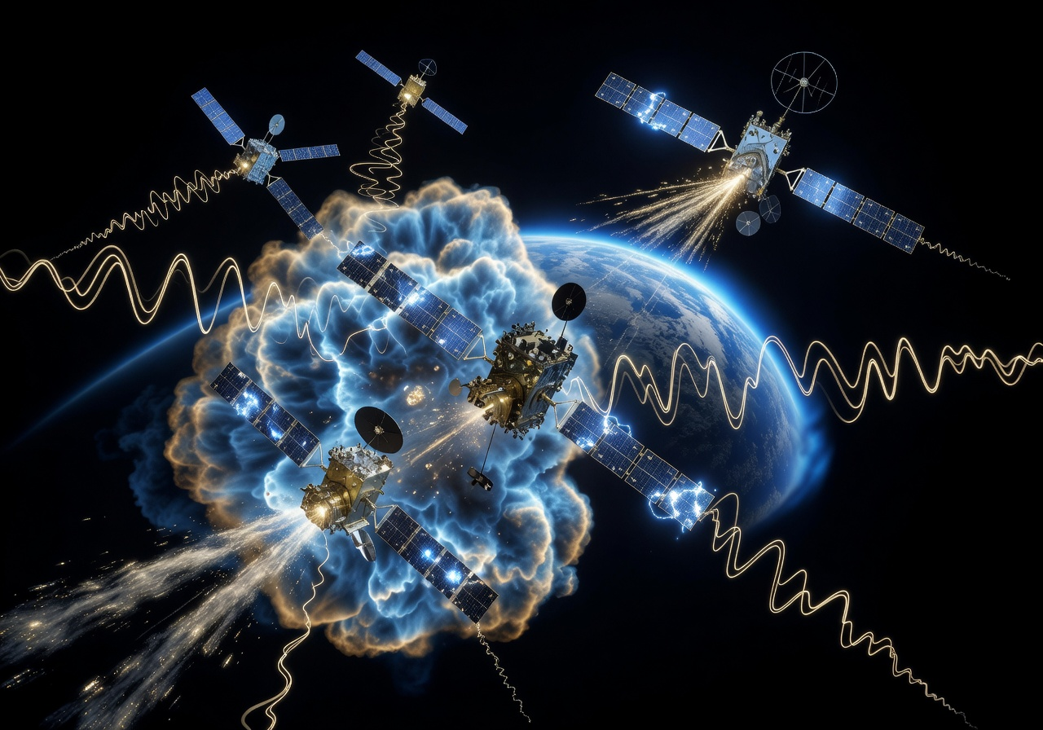Generated by AI

Obviously for every year humankind and our current civilisation is more and more vulnerable since we are getting more dependent on sattellites, digital devices and the electric grid.

Why Another Carrington-Level Storm Is Inevitable
Solar cycles of flare activity pulse every 11 years. We are currently in a cycle which had a low in 2019 and that topped July 2025. Ice-cores show beryllium-10 peaks which is a sign of a major hit on Earth, that a Carrington 1859-scale are recorded in AD 717, 1770, 1839. Today, experts call a Carrington event is probable every 150 years.
Luckily we now monitor the solar space weather with the SOHO and SDO projects. Their coronagraphs spot coronal mass ejections and can provide a warning of 12-48 hours of Earth-directed ones.
What can you do if an alarm goes off and you have 12 hours to prepare?
- Top up everything: charge phones, power banks, laptops, rechargeable lights, and fill all available water containers in case pumps fail.
- Turn off and unplug non-essential electronics (PCs, TVs, extra gear) to reduce surge risk if the grid gets hit.
- Keep at least one simple battery or hand-crank radio, plus spare batteries, ready so you can still get information if internet and mobile networks go down.
- Prepp your home and family as you would do for an extreme weather event.

Tracking and Learning with Earth Moves Watch
The digital Earth Moves Watch get NOAA Space Weather Prediction Center feeds. On the watch we show this as a burst from the Sun (12 o'clock) going towards Earth. When the burst hits Earth, it is deflected and collected by the Earth's magnetosphere which routes the solar plasma towards our north and south pole. Actually much of the plasma is driven towards Earth's nightside because of the shape and compression of the magnetosphere.
On the digital Earth Moves Watch we can show the probablity for aurora as a cloudy light around the proper latitude on the Earth on the watch.
If and when there should come a Carrington level ejection towards Earth, our watch will show that in red light.

Frequently Asked Questions
What was the original Carrington Event?
What damage would a Carrington Event cause to power grids today?
What is the chance of another Carrington-level storm?
How would satellites and GPS be affected?
How can I prepare for a solar storm?
⊙
See this live on the Earth Moves Watch
Open Watch →

The Monthly Ephemeris
One briefing per month, timed to the sky. Upcoming celestial events, what the instruments will show, and one deeper read.

Subscribe

12 emails a year. No spam. Unsubscribe anytime.

Continue Reading
Space Weather

Aurora Borealis & Australis Explained: Complete Guide to Causes, Colors & Viewing Tips
Mar 9, 2026·4 min→
Space Weather

Van Allen Radiation Belts Explained: Earth's Invisible Danger Zone for Space Travel
Mar 9, 2026·4 min→
Natural Time

Earth's 23.4° Axial Tilt: Why It Creates Seasons and Shapes Life (Not Distance to the Sun)
Mar 9, 2026·4 min→

WatchCalendarEphemerisStore
© 2026 Earth Moves AS

